Name_________________________________ Math 226 Test 1 Review
Show all of your work when solving the following problems. Answers without supporting work may not receive full credit.
In the questions below assume that the domain for x is the set of all people and the domain for y is the set of all movies. Write the statement in good English, using the predicates. Do not use variables in your answers.
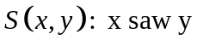
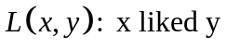

- 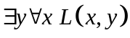

- 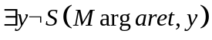

- 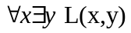

In the questions below, suppose 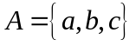 Is it true or False?
- 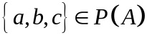

- 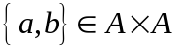

- 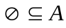

- 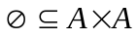

For any subset A and B of a universal set U, prove that the following is true:
- 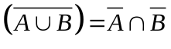
- Does the following rule describe a function with the given domain and codomain? Explain.
Let 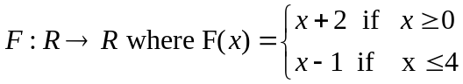

- Suppose 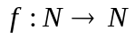 has the rule 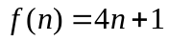, determine whether is onto . (Reminder is the set of all natural numbers, so 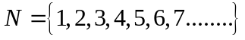). Show all of your work.

- Show the following is not one to one: 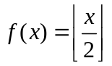

- Suppose 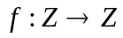 has the rule 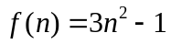. Determine whether is one to one. Show
all of your work.

- Use the definition of big-oh to prove that 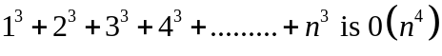.

- Find the sum of products expansion of the Boolean function 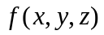 that is 1 if and only if
either

- Draw a logic gate diagram for the Boolean function 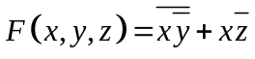

- Draw a single Venn Diagram to represent the sets A , B , C that satisfy all the given
conditions:



